**Author:** Manoj Jauhari (WIPRO Limited)

**The purpose of this document is to make candidates familiar with the Mettl Assessment Tool environment**

**Demo Programming Test Link =** <https://tests.mettl.com/authenticateKey/19ad6bca>

Use the above link to start the demo programming test.

You will be prompted to enter your **Email Id** and **Name**.

In the Email Id field, you must enter your WIPRO Email ID. If you do not have a WIPRO Email ID, use your personal email ID.

**Note:**One email-ID can be used only once for a mettl test. For practicing a mettl test link multiple times, you must enter different email-IDs in each attempt. For example, if your email-id is [ramesh.das@wipro.com](mailto:ramesh.das@wipro.com) you can try the above link once using the email-id [ramesh.das@wipro.com](mailto:ramesh.das@wipro.com) and then multiple times by appending a number to your email-id such as [ramesh.das1@wipro.com](mailto:ramesh.das1@wipro.com), or [ramesh.das2@wipro.com](mailto:ramesh.das2@wipro.com) or [ramesh.das3@wipro.com](mailto:ramesh.das3@wipro.com) or [ramesh.das4@wipro.com](mailto:ramesh.das4@wipro.com) etc.

Once you start the test, the test window would appear as shown below.

The programming test can consist of 1, 2 or more programming questions.

If a programming test consists of only 1 programming question, you will see only 1 section.

If a programming test consists of 2 programming questions, you will see 2 sections, as shown in the below screenshot.

**How do I toggle (move) between the two or more programming questions?**

To toggle (move) between the two (or more) programs, you can either select the program from the **drop-down list** at the top-left corner, OR click on the “**Next Section**” link at the bottom-right corner.

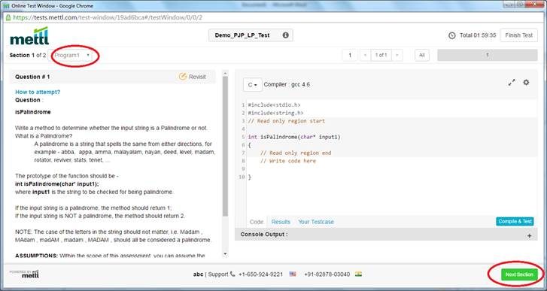

**The Test interface -**

For each programming question, the question text appears in the left-side frame and the code window (with a skeleton code) appears in the right side window. The skeleton code provides a basic structure or a starting point for you to start coding the solution. You are not supposed to change the name of the function, its return type, or its parameters as specified in the skeleton code. You are only expected to write the solution (logic) within the function, without disturbing other parts of the skeleton code.

**Choose the language in which you would code the solution –**

For each programming question, before you start coding the solution, ensure to select the language to be used to write the solution. The language can be chosen using the dropdown list just above the code in the code-window.

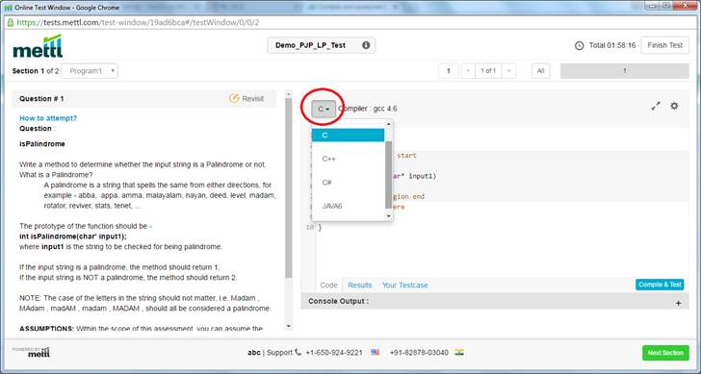

**Write the solution and Compile/test -**

As you write the code, you can click on the “Compile & Test” button to see the result.

The “Results” window would show the compilation errors (if any) or the result of the default test-case.

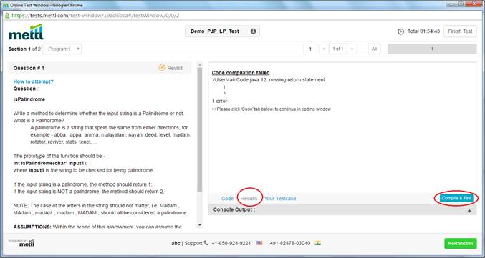

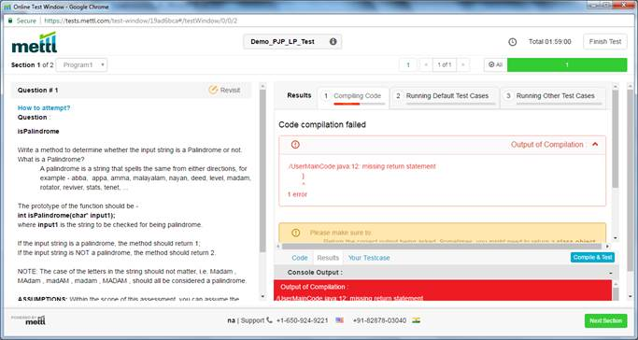

**Try your own test-case values -**

Note that by default the test-engine will show the result of only the default test-cases, i.e. how your code responds to the default test-case values. The default test-case values are stored in the test-engine by the author of the question while creating the question. For assessment purpose, there are multiple test-cases that are run in the background that will obviously **not** be shown to you. You should therefore use the “Your Test case” feature, for specifying your own set of input values and check whether your code processes the test values as expected.

**NOTE:** When using the “Your Testcase” feature, ensure that you select the “Use my testcase value” checkbox.

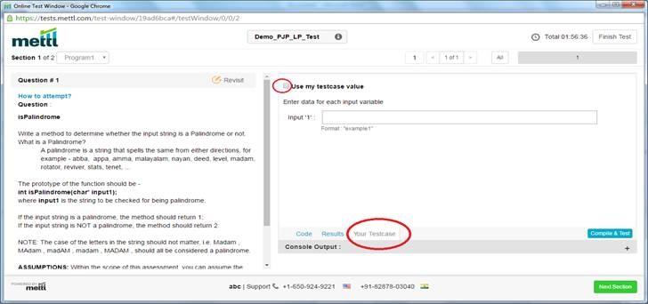

**How to decide my test-case values -**

It is your (the programmers) responsibility to test your code with all possible variations and combinations of input values. You must therefore read the question description carefully and understand what types (variations) of input-values are expected to be handled by your code. On a piece of paper, you must then prepare the list of input values that you would expect your code to handle, and also calculate what should be the expected output for each of those input values. Once you have this list of “input value and expected output”, you can use the “Your Testcase” feature on mettl to check whether your code produces the expected output for each of the input values. If the output produced by your code matches the expected output for each input value, your code is fine. If the output for an input value does not match the expected output, you will need to correct your code and again try the input value.

**IMPORTANT NOTE to be considered while using “Your Testcase” feature:**

·         To specify **string** input values, enclose them within double-quotes, for e.g. “Wipro”, “Wipro Limited”, “Programming is fun”, etc.

·         To specify **array** input values, specify the values of array-elements enclosed within curly braces. Ensure that there are NO space characters anywhere between the curly braces or between the array-elements. For e.g. {14,12,7,9091,672,854,11}

·         To specify integer input values, specify them as plain numbers, for e.g. 123, 156, etc.

·         See example in the next page.

Below image shows an example of specifying an integer as well as an array of integers, as input values.

In this example -

Input1 is of type integer, so the value is directly specified.

Input2 is of type “array of integers”, so the values are specified within curly braces and there are NO space characters either after the curly brace or before/after the commas.

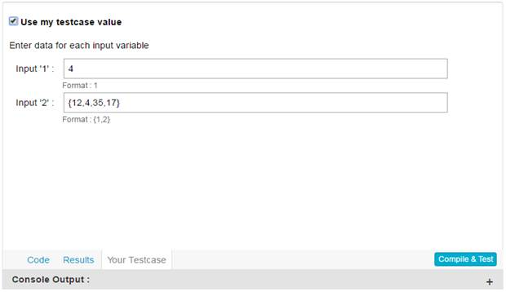

**IMPORTANT:** As mentioned earlier, an important point to note is that when you want mettl engine to use your test-case values, ensure to select the checkbox “Use my testcase value”. If not, the mettl engine will use the default testcase value.

**How do I submit my code for final evaluation?**

Once you have coded and tested the solution for all the programs in your test, you can click on “Finish Test” button at the top-right corner of the window to submit your code for final evaluation. Note that clicking on “Finish Test” button submits your code and ends your test. You will be unable to make any further changes to the code after final submission. So, ensure to click on the “Finish Test” button only once you have coded and tested the solution for all the programs in your test.

**Can I use the “Compile & Test” button multiple times?**

Yes, you can use the “Compile & Test” feature multiple times to compile your code and test it against the default testcase value or with your testcase values.

Hope the points mentioned in this document have helped in making you familiar with the important aspects of solving programming questions on mettl. To make yourself more comfortable with mettl interface, please go ahead and solve the demo questions available in the below link. Ensure to use the “Your testcase” feature to test your code properly before submitting your solution.

**Demo Programming Test Link =** <https://tests.mettl.com/authenticateKey/19ad6bca>

Happy Coding!!